Homepage UI Snap1:



HomePage UI Snap2:



LoginPage UI:

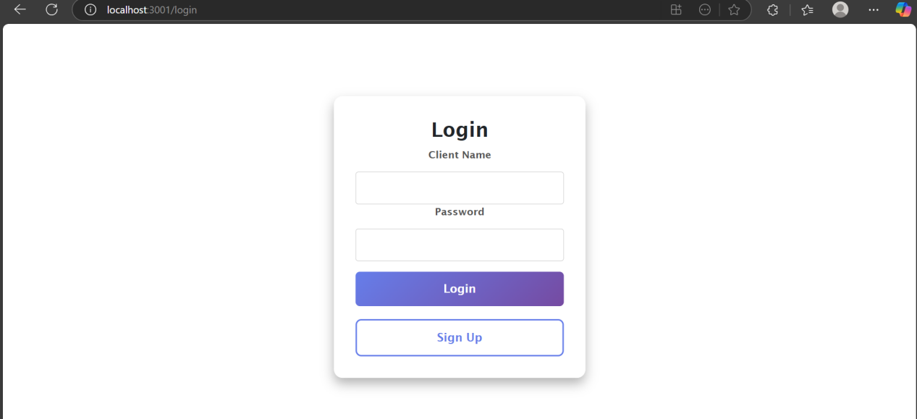

Signup/logup UI:

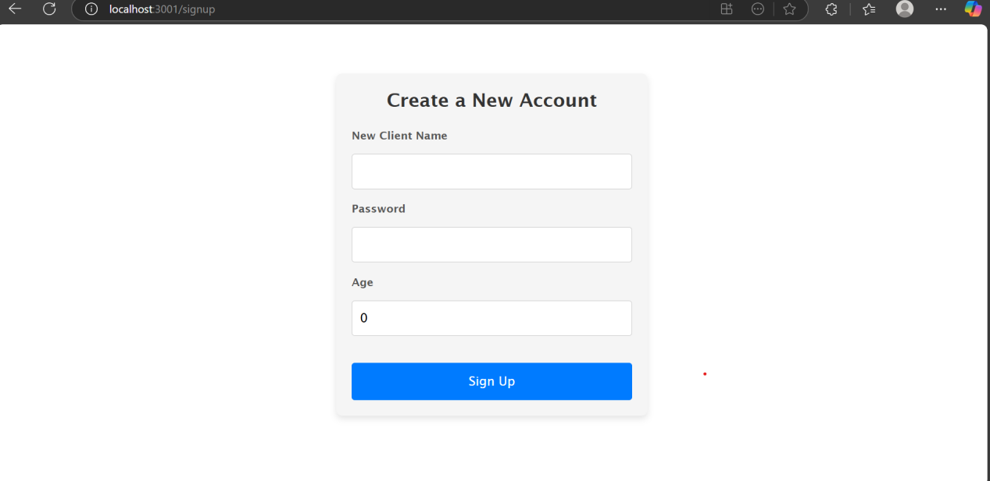

TravelSchemas UI(Design Enhancement on progress):

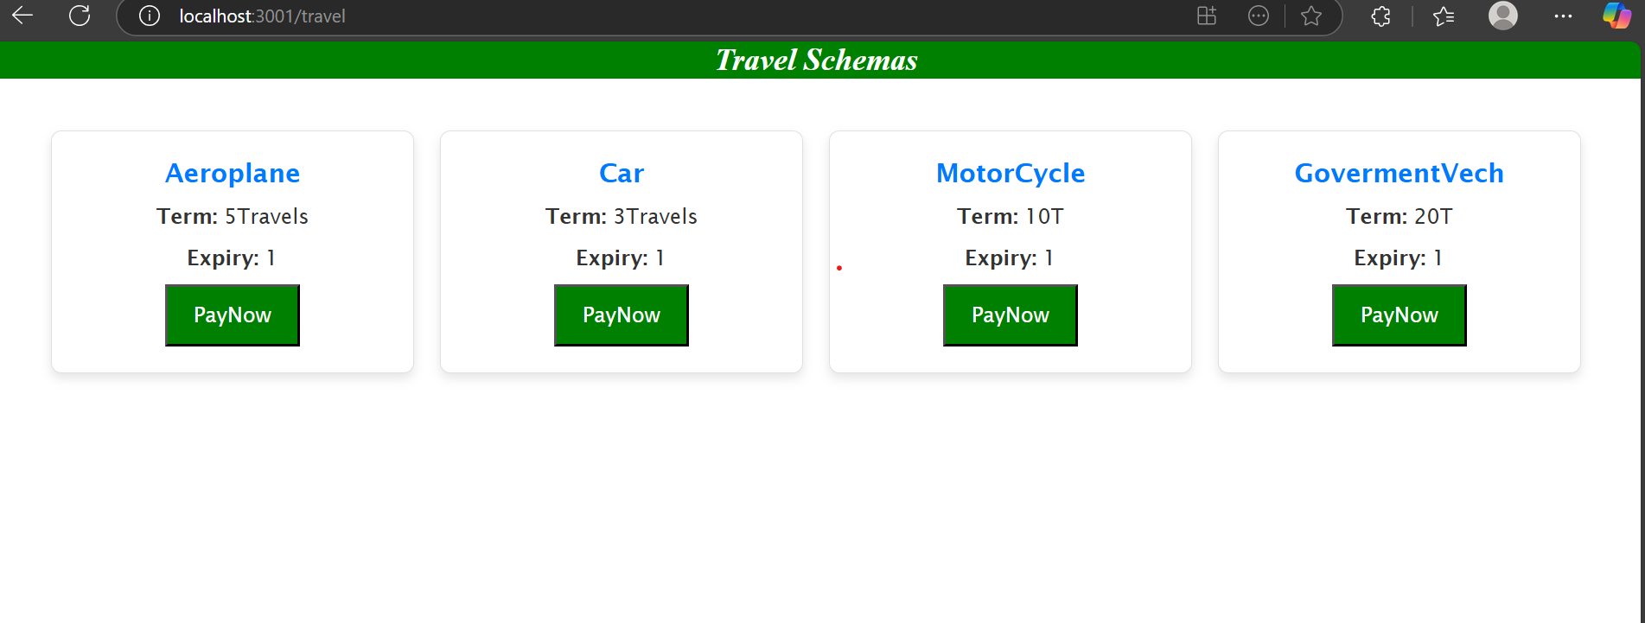

LifeInsurance Schema UI (Design Enhancement on progress):

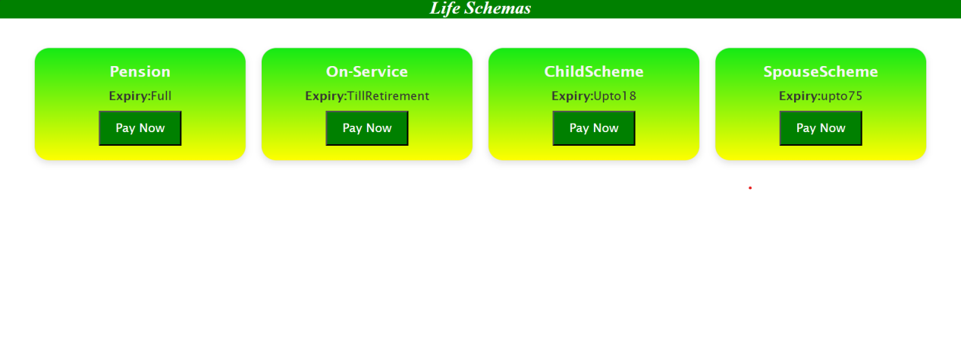

Payment Gateway Snap:

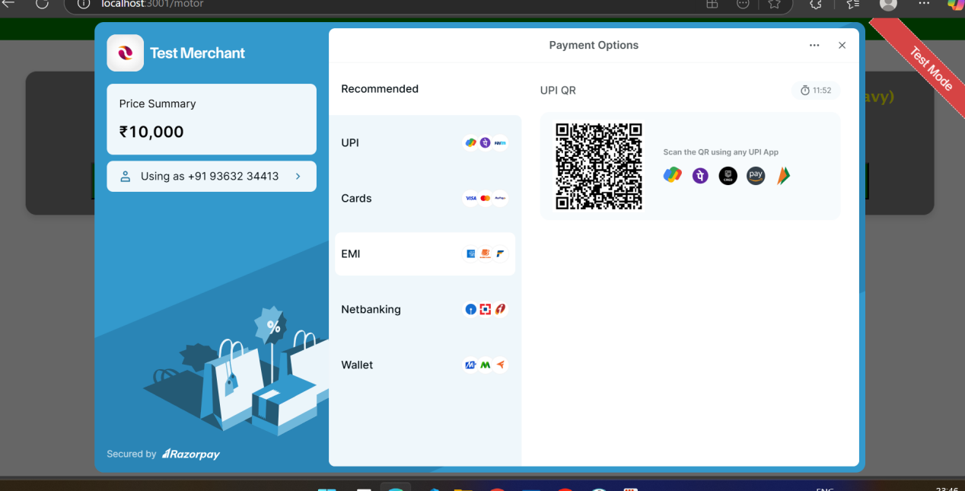

MotorInsurance schemas(Design Enhancement on progress):

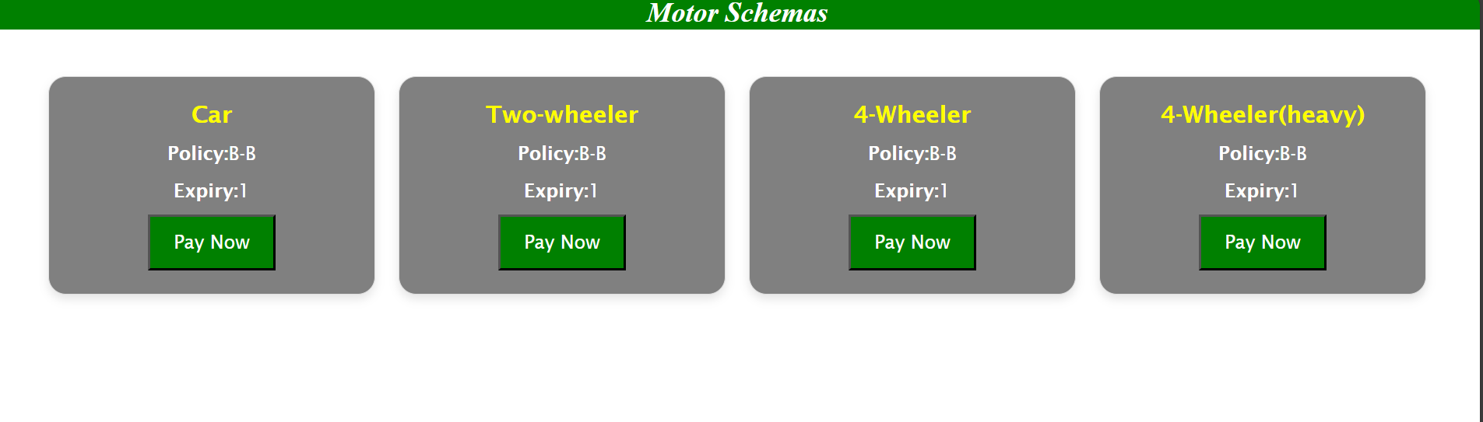

**Notes/Explanation(Designs):**

* The Homepage UI is built with React-bootstrap.Contents: Navbar with logo and login and logout.Carousel slides to display all three insurances,three cards to know the schema of all three insurances and a footer to display about and contact details.
* Login Page is built with React-bootstrap.Which gives a simple and Elegant UI experience for users
* All three insurance pages are built with 3-4 cards which automatically fetches data from SQL server/database.Design is on process trying to shift to material UI(antd)
* Sign up is built with react-bootstrap.
* Payment Gateway is derived from Razor pay test mode.

**Notes/Explanation(Functionalities):**

* The Homepage is a hardcore design which just navigates to the pages using useNavigate react-hook.With automatic carousel Slides
* The Login page fetches the data using API integration or CRUD operations which verifies the user have registered already if not pulls error invalid credentials.Also has a sign up tab for new user to register.Session enrolled.
* The Sign up page consist of three essential field Name,Password,Age which is managed by state management with react-hooks like useState. It receives data from user and inserts the data in database using axios methods,API CRUD operations.
* The three Insurance pages has the same functionalities fetches using axios.get it data and display it has cards within pay now button which enables the user to enter the payment gateway.
* The whole Project is responsive for all media like desktop,mobile and so on.
* Backend: Contains all API calls,Database Connection, Session Storage and Winston log files. It uses Expressjs,MySQL2,CORS,Winston and so on…

Coding Placement structures:

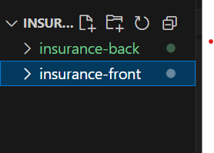

Back-End file structure(nodejs):

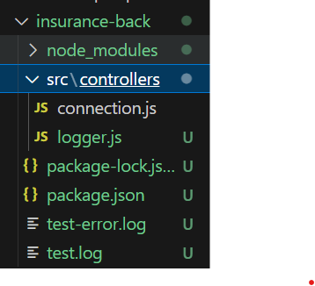

Front-End file structure(react.js):

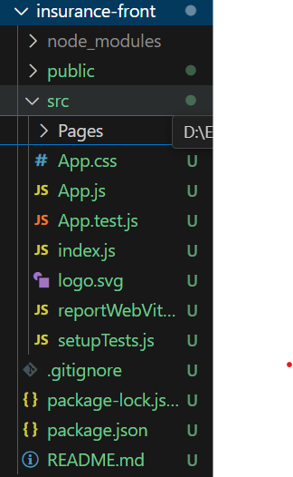

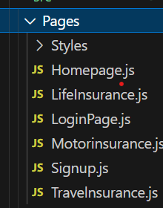

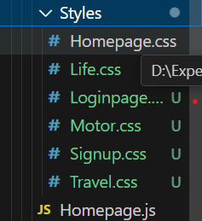

Full view:

